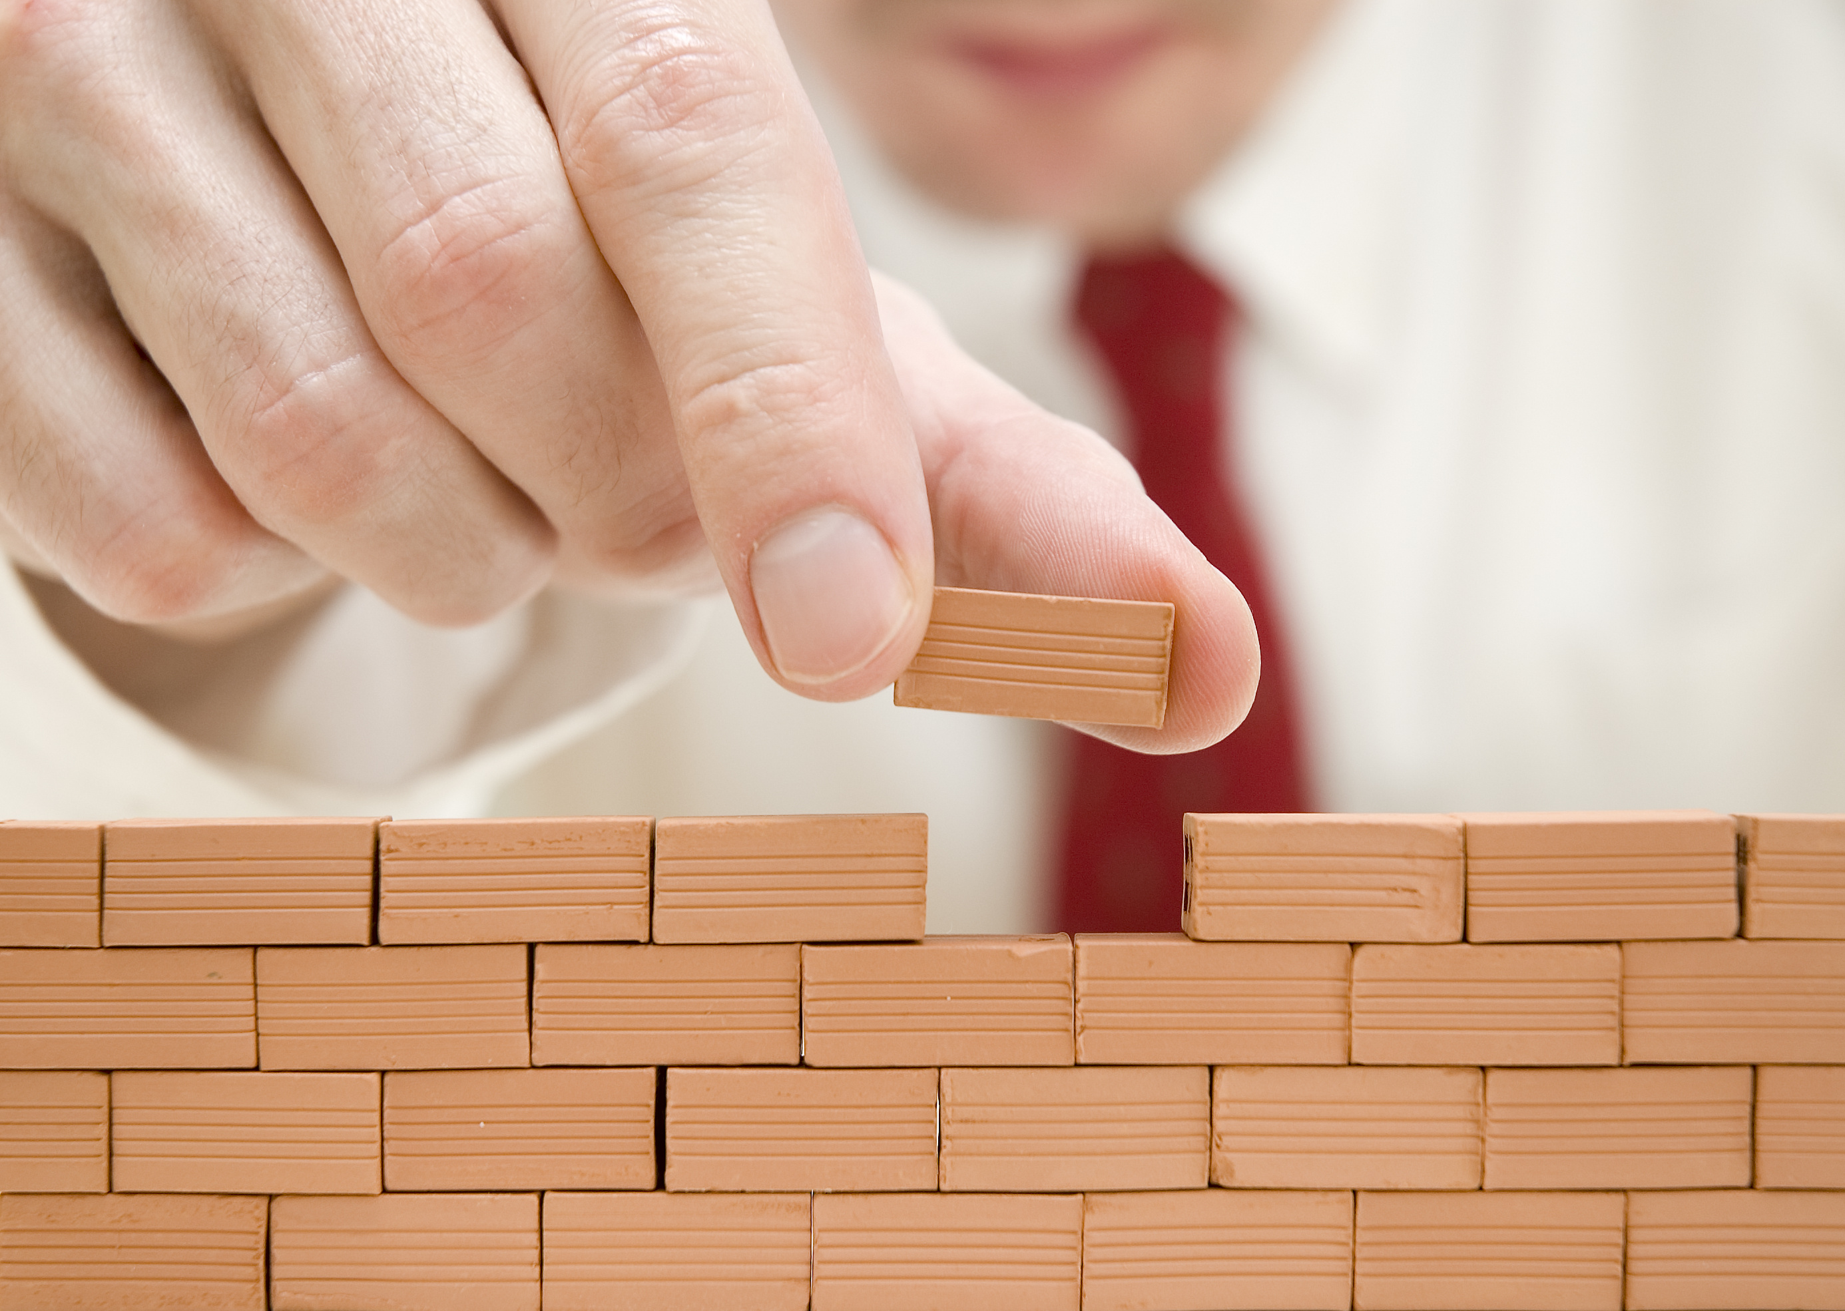

WHERE TO START

WHAT HAPPENS ON SITE

WHAT ARE THE BENEFITS

10 Advantages of

Design Build

CONSUMERS GUIDE

The Design-Build system of project delivery has many advantages over the traditional system where an owner himself hires an architect for design, engineers for technical trades, interior designers and a builder for construction. These are all independent people running independent businesses. Coordination between these individual teams while keeping track of the overall performance and progress of the project can get very challenging, often long and tortuous.

The roots of the Design-Build system came from the nineteenth century figure of the Master Builder, men who had the highest respect from their peers and clients, due to their mastery and knowledge.

Even though for reasons unknown, in the twentieth century most projects were being executed under the traditional system and professionals continued to receive training geared to perform under this same arrangement. However Design-Build has been gaining more and more leverage as clients and project owners have started to understand and realize several benefits that this system brings.

It is true that not everybody can be a Design-Builder. It takes an architect with qualities and talent as a designer, while being pragmatic, practical and technical as an engineer at the same time. It takes deep knowledge and understanding about various systems, construction process along with an unquestionable honesty and reputation. Here we will focus on ten reasons on why the Design-Build system is better and what benefits or advantages it brings the owner.

1. More comprehensive site evaluation

One of the first key steps to a successful project is proper site selection and evaluation. Owners often make the mistake of buying property without consulting a professional who can help them make the right choice.

Buyers usually turn to one of three kinds of people for advice when considering purchasing a property – realtor, architect or builder. Honest realtors who don’t sweet talk buyers just to make a sale may be able to give the right advice at times. However, this will usually depend on the kinds of homes the realtor has seen built on properties previously sold. And, although realtors might have some level of vision, they might not have the professional training necessary to give an overall well informed advice that covers various critical aspects.

More savvy buyers will turn to either an architect or a builder for advice when evaluating a property. This is of course the recommended course of action, where the buyer will be able to get advice from professionally trained individuals who are from the field of creation or construction.

**A Design-Builder** will have a compounded vision derived from several different evaluations. He will have the ability to consider and weigh various criteria into site election, evaluate as well as visualize the way a structure could be designed while keeping in mind logistics and construction of the structure. The design-builder will consider and evaluate aspects and issues often overlooked by an architect and weigh in these into the preliminary cost projections for one site vs. another.

1. Better design through understanding construction

Few architects’ focus very strongly on their ability to create good designs and on what sets them apart. However, in doing so, they often completely ignore potential structural issues and complications that could arise due to an impractical built form or shape. They completely depend on the structural engineers to figure it out while in reality it can be incredibly challenging to actually build some of those forms. It can either get extremely expensive or sometimes it’s just not possible to make an odd built from that can also be structurally stable.

This is when difference of opinions start between architects and structural engineers causing delays in the progress of the project. The engineer starts offering solutions that may require slight design alterations in order to make the built form structurally stable, while the architect or designer is not willing to accept and incorporate those changes or alter his overall design in any way. The project can remain to a standstill until all concerned parties are in mutual agreement about design and structural issues.

A Design-Builder is a better alternative to the above because he will work in the overall interest of the owner or client. He has the ability to create and design while taking into account, structural and engineering challenges. He also has an in depth understanding of the intricacies of construction and how overall systems are supposed to work. This allows the design-builder to properly design a project while keeping all technical aspects in mind. And since the design has already taken into account and addressed potential issues at the concept stage itself, it becomes easier for the engineers to execute on site without making any major alterations or changes. The project thereby can move on smoothly without any delays due to difference of opinions amongst professionals.

The owner or client emerges a winner in this case, since not only the project is executed in a shorter time frame, with proper provisions for systems but also with integrated and smarter overall problem solving potential.

1. Better construction through understanding design

In **traditional construction delivery system,** the architect hands over the design to a contractor or a builder who will eventually construct and execute the project. This requires the contractor or builder to read and learn the drawings, interpret the design and build the project from a combination of information acquired through that process from various different resources and teams.

This could lead to problems arising from the contractor who may or may not have fully understood the drawings. If there are issues that were not properly solved or addressed during the design phase but surface during the construction phase, then those need to be re-addressed. Usually, in such cases the contractor will have to go back to the architect and wait for a solution. It may take the architect’s office days or weeks to revert which in turn causes delay in the overall duration of the project.

A **Design-Builder** however, will be able to perform construction of the project without any of these glitches or drawbacks, since they already know the project inside out right from the start. There is nothing new that they need to understand or interpret. The project execution will be fairly straightforward and simple since in most case any potential issues will have been addressed during the design phase itself.

If surprises do come up during construction, they are minimized and solved relatively easily and sooner since the design-builder himself has in-depth knowledge and training for both, the overall design as well as its technicalities.

1. Enhanced client communication

In the **traditional system**, the owner has to go through a series of hoops to be able to finally build and complete his project. First the owner would select an architect who will design the project, then the design would have to go into construction drawings development phase. For this, the client will usually have to find engineers from different trades to deal with different aspects of the project. Once the project is fully done on paper, it goes into actual construction where the client then needs to deal with the contractor or builder.

With involvement of so many different professionals in the project, it becomes difficult for the owner to coordinate, figure out the right path of action and often putting him, the client, in the middle of discussions and debates between consultants. The owner ends up spending much more time in aligning the teams and defining a plan of action than he’d really like to.

Since the **Design-Build** **system** involves having a single firm perform the entire process, starting from design through construction and execution, the client has to deal with a single point of contact for all communication on the project making his own life much easier and hassle free. Coordination between professionals specializing in various individual aspects of the construction process is smoother since they all are from the same team or firm and most likely know the project inside out right from the start. Also, in case coordination issues or any other technical issue arise, it is the responsibility of the design builder and not that of the owner to tackle them.

1. Better chances of getting the project built

The traditional **Design-Bid-Build system** usually shows disconnect many architects have with realities of construction and the costs associated with it. Typically, finished design is supplied to the owner who then puts it out for different contractors to bid upon. These bids usually come back with considerably higher quotes than the owner had initially budgeted for. As a result the owner has to go back into the negotiation process with contractors to see who will provide the best price. This however can get tricky and even dangerous, since chances of the lowest bidder compromising on quality in order to meet the lower costs rises.

Even worse situations arise when the project costs shoot way beyond the owner’s original budget owing to the designer’s shortsightedness and disconnect with practicality. And at this point there might be no other alternative but to redesign the entire project. This can set the project back by months and not to mention a huge disappointment to the owner who has already set his mind on a current design that just cannot be built anymore.

A **Design-Builder** has first-hand experience, detailed information of costing and overall a much better understanding of the real costs involved in a project. This gives him the ability to design a project within budget constraints. Usually, the percentage of design-build projects that end up shooting over budget is much lower than the projects done by the traditional method.

Overall, projects done in the design-build system end up having a much better chance of completion than projects done by the traditional system.

1. Value based project design and results

In a **Traditional Project**, the owner must often manage different personalities and agendas of independent service providing professionals as each of these professionals have only their personal interests in mind. The designer wants his design to excel even though it may be overlooking other important technical issues. Engineers often concentrate on their systems alone, even if it detriments the design. And the owner is now left alone to evaluate and decide the best option from alternatives given to him and he has to do so without any formal training, simply based on his best judgment or common sense.

In a **Design-Build Project**, the design-builder performs a careful balancing act, weighing in design, technical as well as budgeting aspects at all times and thereby provide the owner with best possible solutions. He takes into account all aspects and criteria in order to make an informed decision. This combination of factors proves beneficial for the owner as he can now rest assure of his project being completed on time, with minimum compromises and headaches and most importantly within budget.

1. Faster overall delivery

We have already seen some of the problems that commonly face projects done in the traditional Design-Bid-Build system. The costing disconnect of the designers, lack of agreement between designer and engineers, the delayed timeframe due to redesigns or selection of contractor within budget etc., all lead to an extended timeframe.

Now, add another factor - getting permits. In the traditional system, the project permit is done only after selecting the contractor and the final contractor eventually handles the permit acquisition process. This law may differ from country to country however typically this is done in order to put the right name of the professional responsible for ‘technical direction’ on any project.

A **Design-Build** project does not lose much time owing to miscommunications between two teams, budget discrepancies, back n forth between contractor bids etc. The project is often able to overlap activities of costing and budgeting with that of the design process thereby making the overall timeframe shorter. Additionally, since the client hires the design-builder to perform the construction right from the start, the permits process can be initiated as soon as the design is completed and final sets of plans and copies are printed. This saves a lot of time between completion of design, sifting through several bids and finally hiring the right contractor.

1. Single point of responsibility

When a project is executed in the **traditional system**, it is usually hard to determine who exactly is responsible if and when something goes wrong. None of the employed parties would want to take responsibility single handedly in order to avoid penalties of any kind and thus causing delays in the progress of the project.

In a **Design-Build** project however the client has a single person to deal with and that person is responsible for the entire project. This not only makes things easier for the owner, but it also adds additional responsibility and pressure on the design-builder to make sure that everything is done right and mistakes are held to an absolute minimum.

In this business word of mouth is extremely essential for growth of business, therefore a Design-Builder has a vested interest in making sure that the project is executed as smoothly as possible and is eventually successfully completed.

1. Decreased administrative burden

In the Traditional System, the client ends up spending a large amount of time in administrative issues, managing large amounts of paper work and bills for the project coming in from all directions. Often, the owner ends up spending so much time rummaging papers and bills that he is left with little time to devote to the project itself. This can cause for him to make some delayed decisions affecting the progress of the project.

In a **Design-Build Project**, the administrative burden for the owner is reduced since all bills come from a single source; therefore the amount of time spent on checking and reviewing information is greatly reduced. The owner thus has more time to dedicate to the project itself, enabling him to make quicker choices and decisions.

1. Tighter knowledge and control of the project

In a **Traditional Project**, the owner will be solely responsible for management of various aspects of the entire project including design, technical decisions, budgeting etc. Most owners are not good at doing all of this at a time since their time is already invested in their own professional commitments. All hired professionals will handle only their part of the job and will perform within the boundaries of their trade. Often, especially in the design and construction of custom homes, the owner ends up being the one who makes all the decisions.

In a **Design-Build Project**, a single firm handles everything, which creates a huge advantage for the owner as the coordination and management of the entire project is now the responsibility of that firm’s lead. If need be, the owner only needs to manage this single point of contact. This firm or its team has an integral knowledge about all aspects of the project from the start including design, budget, structural aspects etc. This allows the team members to have a better understanding and grip on the overall project enabling them to work hand in hand with each other and giving the owner a project experience that is smooth and enjoyable.