Design Firm Name

Mobile
555 555 5555

Telephone
555 555 5555

Email
email@designfirm.com

Website
www.designfirm.com

Choosing an architect isn’t easy.

You need the right architect who has the specific skill for your character home project and there is a right ‘fit’ between you and your architect.

This may or not be me!

In our experience the best way of finding out whether we are the right ‘fit’ is to fully understand what you are looking for; and this is achieved through our initial consultation session.

If for some reason we then discover that we are not an ideal ‘fit’ then you are free to take the report to another designer for them to continue the process.
INITIAL CONSULTATION BOOKING

When considering renovating your character home the Initial Consultation with [architect name] is the first step. Here is why…

- To obtain a registered architect’s opinion on the feasibility of the project. [architect name] is [location] leading [project type] expert.
- To produce an outline brief detailing rooms, sizes, orientation etc...
- To discuss potential solutions in outline form
- To discuss ‘look and feel’ of a potential scheme
- To discuss the planning viability of the project and your ideas
- To give outline construction costing for budget usage
- Outline the requirements for Building Regulations (xxx)
- All travel prices included in price for Wellington region (other areas beyond this area are priced at ‘cost’)
- Production of report including the above
- Report includes schedule of services & fee proposal on next stages of project
- Consultation cost credited to account on progression to next stage

A doctor wouldn’t operate without a proper diagnosis; this initial consultation works in the same way. This initial consultation starts a strategy designed to precisely understand your requirements, then to give findings and recommendations and a plan to move forward with a timeline and budget.

- - - - - - - - - - - - - - - - - - - - - - - - - - - - - - - - - - - - - - - - - - - - - - - -
Yes I would like to book an initial consultation with Mona Quinn as described above.
Enclosed is a cheque/credit card details for $492.00 made payable to Callidus Architects for this initial consultation. Receipt sent upon payment.

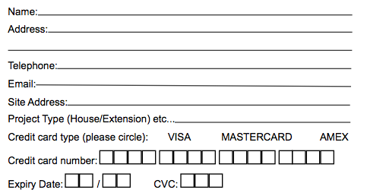

Return by post to
Firm Name
Firm Address

Or scan and email to
email@designfirm.com

